**Sales Analysis Report – ShopNest Store**

Shabeeb Mon M

20/07/2025

**1.Identify and visually represent the top 10 product categories by total sales**

**Top 10 Product Categories by Total Sales**

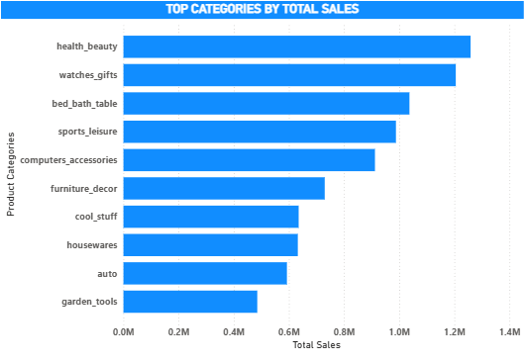

The chart displays the top 10 product categories based on their total sales, measured in millions (M). The categories are ranked in descending order of sales, with the following key insights:

* **Health & Beauty** leads with the highest total sales, exceeding 1.25M, indicating it as the most popular category.
* **Watches & Gifts** follows closely, with sales around 1.21M, showing strong performance.
* **Bed, Bath & Table** ranks third, with sales approximately at 1.04M.
* **Sports & Leisure**, **Computers & Accessories**, and **Furniture & Decor** show a gradual decline, with sales ranging from about 1.0M to 0.73M.
* **Cool Stuff**, **Housewares**, **Auto**, and **Garden Tools** have the lowest sales among the top 10, each below 0.7M, with **Garden Tools** at the bottom around 0.5M.

The chart highlights a significant drop-off in sales after the top three categories, suggesting a concentration of demand in **Health & Beauty**, **Watches & Gifts**, and **Bed, Bath & Table**, while the remaining categories show more moderate and evenly distributed sales.

**Business Takeaways:**

• Focus marketing and stock optimization on **top-performing categories** like Health & Beauty and Watches & Gifts.

• Consider upselling or bundling in **mid-tier categories** like Sports & Leisure and Computers.

• Explore why categories like Auto and Garden Tools are lower — is it due to seasonality, pricing, or visibility?

**2. Determine the number of delayed orders in each category. An order is considered delayed if the actual delivery date is larger than the estimated delivery date.**

**Delayed Order Analysis**

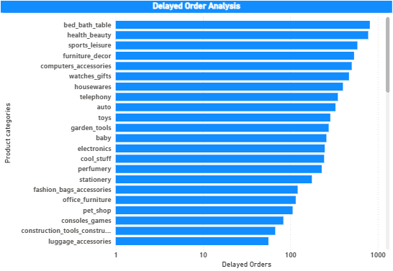

The chart displays the number of delayed orders across various product categories, where a delay occurs if the actual delivery date exceeds the estimated date.

Key insights include:

* **Bed, Bath & Table** tops the list with around 810 delayed orders, indicating significant delivery challenges.
* **Health & Beauty** is nextdelayed product category with around 776 delayed orders.
* **Sports & Leisure**, **Furniture & Decor**, and **Computers & Accessories** each exceed 500 delayed orders, showing notable issues.
* Categories like **Watches & Gifts**, **Housewares**, and **Auto** have moderate delays (300-500 orders).
* Product categories such as Diapers and Hygiene, flowers and Party Suppliers are the least Delayed items.

The findings highlight **Bed, Bath & Table** as the most affected, with a steep decline in delays across other categories, suggesting targeted improvements are needed for the top-delay categories.

**3. Create a dynamic visual that compares the number of delayed orders to the number of orders received earlier for each month. Utilize the drill through cross-report feature to provide a detailed analysis of late and on-time deliveries.**

**Monthly Comparison of Delayed and On Time Orders**

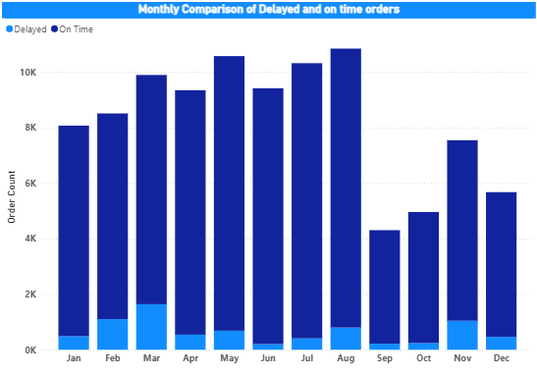

The chart illustrates the total order count (in thousands) per month from January to December, segmented into delayed (dark blue) and on-time (light blue) orders.

Key insights include:

* **August** peaks with the highest total orders, exceeding 10K, with a significant portion on time and a smaller delayed segment.
* **May, and July** also show high totals (around 8K-10K), with a notable on-time majority.
* **September** has the lowest total, around 4K, with a lowest delayed orders.

The findings suggest a peak in orders during mid-year (July-August), with September showing the weakest performance and March Showing highest delay ratio, indicating potential operational challenges during that period.

**4. Analyze the most frequently used payment methods by customers using a visually appealing representation, such as pie chart or other suitable visuals.**

**Most frequently Used Payment Methods**

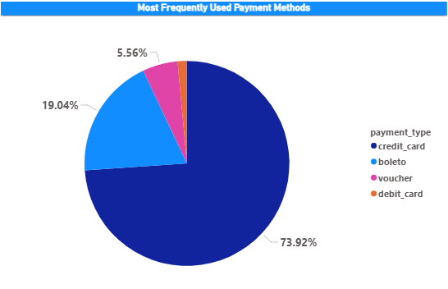

The chart is a pie chart showing the distribution of payment types as percentages. Key insights include:

* **Credit card** dominates with 73.92%, indicating it is the most popular payment method.
* **Boleto** accounts for 19.04%, showing a significant but secondary preference.
* **Voucher** and **Debit card** have much smaller shares, at 5.56% and a minimal portion, respectively.

The findings highlight a strong reliance on credit cards, with boleto as a notable alternative, while voucher and debit card usage remains limited.

**5. Determine top 10 highest-rating products and bottom 10 lowest-rating products using a bar or column chart.**

**Product Rating Analysis**

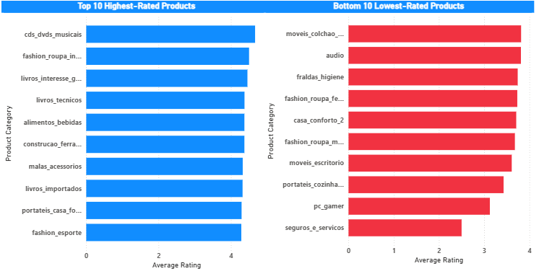

The chart compares the "Top 10 Highest-Rated Products" and "Bottom 10 Lowest-Rated Products" by average rating across various categories. Key insights include:

* **Highest-Rated Products** (blue bars): Categories like cds, dvds and musicals are top rated Product Categories.
* Fashion_roupa_infanto_juvenil all exceed an average rating of 4, indicating strong customer satisfaction.
* **Lowest-Rated Products** (red bars): Categories such as movies, audio have average ratings below 4
* Surguros_e_servicos is the least rated product category, suggesting significant customer dissatisfaction.
* The highest-rated products consistently score above 4.5, while the lowest-rated products fall below 2.5, highlighting a clear divide in performance.

The findings reveal a notable disparity, with entertainment and fashion items leading in ratings, while furniture, hygiene, and service-related categories lag.

**6. Identify and visually represent states with high and low sales, providing a clear understanding of regional sales performance.**

**Sate-wise Sales Analysis**

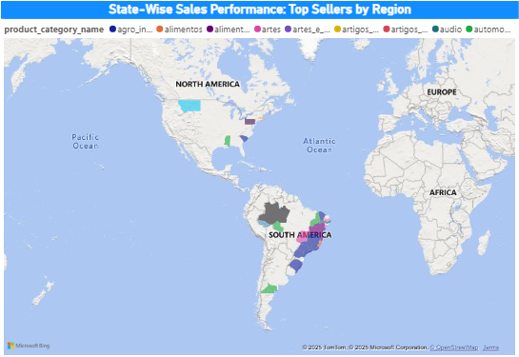

The map titled visually represents sales performance across North America, South America, Europe, and Africa, with states shaded by product categories.

Key insights include:

* **South America** shows the most activity, with Brazil highlighted in multiple colors, indicating diverse top-selling categories.
* **North America** has limited shaded states, suggesting lower sales diversity or concentration.
* **Europe** and **Africa** have minimal shading, pointing to sparse high-sales regions.
* Categories like agro_industria_e_commercio, alimento_bebidas,artes, automotive , and telefoonia appear more prominent in South America, while others are less represented.

The findings highlight South America, particularly Brazil, as a key sales region, while North America, Europe, and Africa show less significant or concentrated sales performance.

**7. Investigate and visualize any seasonal patterns(Quarterly) or trends in sales data over the course of the year.**

**Seasonal Sales Patterns**

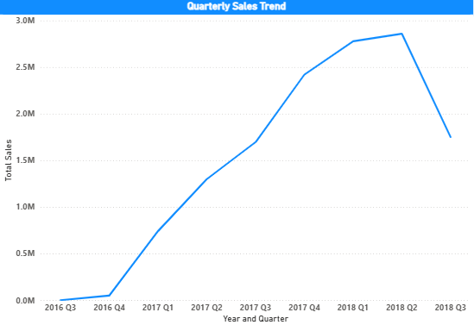

The chart visualizes total sales (in millions) from Q3 2016 to Q3 2018, highlighting quarterly trends and seasonal patterns. Key insights include:

* Sales start low in Q3 2016 (near 0M) and show a steady increase through 2017, continuing to rise until Q2 2018, peaking at around 2.85M.
* A decline begins after Q2 2018, dropping to approximately 1.75M by Q3 2018.
* The most significant growth occurs between Q4 2016 and Q2 2018, suggesting a strong upward trend, possibly driven by seasonal demand in late 2017 and early 2018.
* The drop after Q2 2018 indicates a potential seasonal downturn or market shift.

The findings suggest a seasonal peak in Q2 2018, with a clear upward trend from 2016 to Q2 2018, followed by a decline, pointing to fluctuating quarterly performance.

**8. Determine total revenue generated by Shopnest store and analyze how it changes over time (Yearly). Represent this information through suitable visuals to highlight trends and patterns.**

**Revenue Analysis**

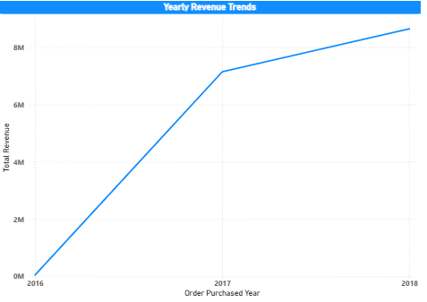

The chart displays the total revenue (in millions) generated by Shopnest store from 2016 to 2018. Key insights include:

* Revenue starts at approximately 0M in 2016 and shows a steady increase.
* A notable rise occurs between 2016 and 2018, peaking at around 8.64M by the end of 2018.
* The overall trend indicates consistent growth over the three-year period.

The findings highlight a strong upward revenue trend for Shopnest, with significant growth from 2016 to 2018, suggesting successful expansion or increased sales over time.